# ARDUINO DUE & ADAFRUIT FEATHER M4 EXPRESS

## Abstract

This review provides an analysis of two influential 32-bit microcontrollers:

* Arduino Due built upon the ARM Cortex-M.
* Adafruit Feather M4 Express, which leverages the ARM Cortex-M4F.

It delves into their core architectures, peripheral sets, memory organization, power management features, and software development environments, including the insight of library support and real-time capabilities.

A comparative analysis highlights their distinct strengths and weaknesses in terms of computational throughput, floating-point performance, memory hierarchy, I/O capabilities, and energy efficiency.

Crucially, the review critically evaluates their suitability and inherent limitations for deployment in satellite projects, with a particular focus on CubeSats (nanosatellites with a standardized size and form factor). This assessment considers the harsh space environment, including radiation effects (TID and SEEs), thermal vacuum conditions, power budget constraints, and the reliability demands of space missions, offering insights into necessary mitigation strategies.

## 1. Introduction

The increase of 32-bit microcontrollers (MCUs) has revolutionized embedded system design, offering a significant leap in processing power, memory capacity, and peripheral sophistication over their 8-bit predecessors. This advancement has enabled more complex applications and has democratized access to powerful computing for hobbyists, educators, and professionals alike.

The Arduino Due and the Adafruit Feather M4 Express stand out as popular representatives of this trend, each catering to different design philosophies and application niches. The Arduino Due based on the Atmel (now Microchip) SAM3X8E, was Arduino's pioneering foray into the 32-bit ARM world. The Adafruit Feather M4 Express, featuring the Microchip ATSAMD51, embodies a more modern approach with a focus on performance, Python integration, and a compact, extensible form factor.

The allure of Commercial-Off-The-Shelf (COTS) components, including these MCUs, for space applications, especially in the blooming CubeSat sector, is undeniable due to reduced costs and faster development cycles. However, this approach necessitates a thorough understanding of the components' capabilities and, more critically, their vulnerabilities in the unforgiving space environment. This review aims to provide that understanding for the Due and Feather M4 Express.

## 2. Arduino Due: The 32-bit Arduino Pioneer

The Arduino Due, launched in 2012, represented a paradigm shift for the Arduino platform, moving from the 8-bit AVR architecture to a 32-bit ARM Cortex-M3 core.

2.1. Core Architecture and Detailed Specifications

The Arduino Due is powered by the Atmel SAM3X8E microcontroller.

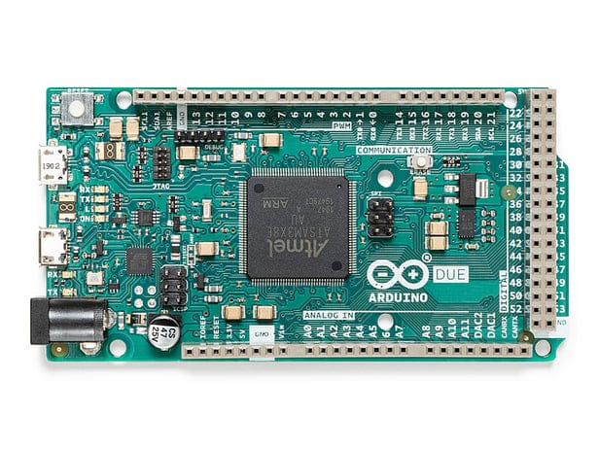

Figure 1: Arduino Due MCU

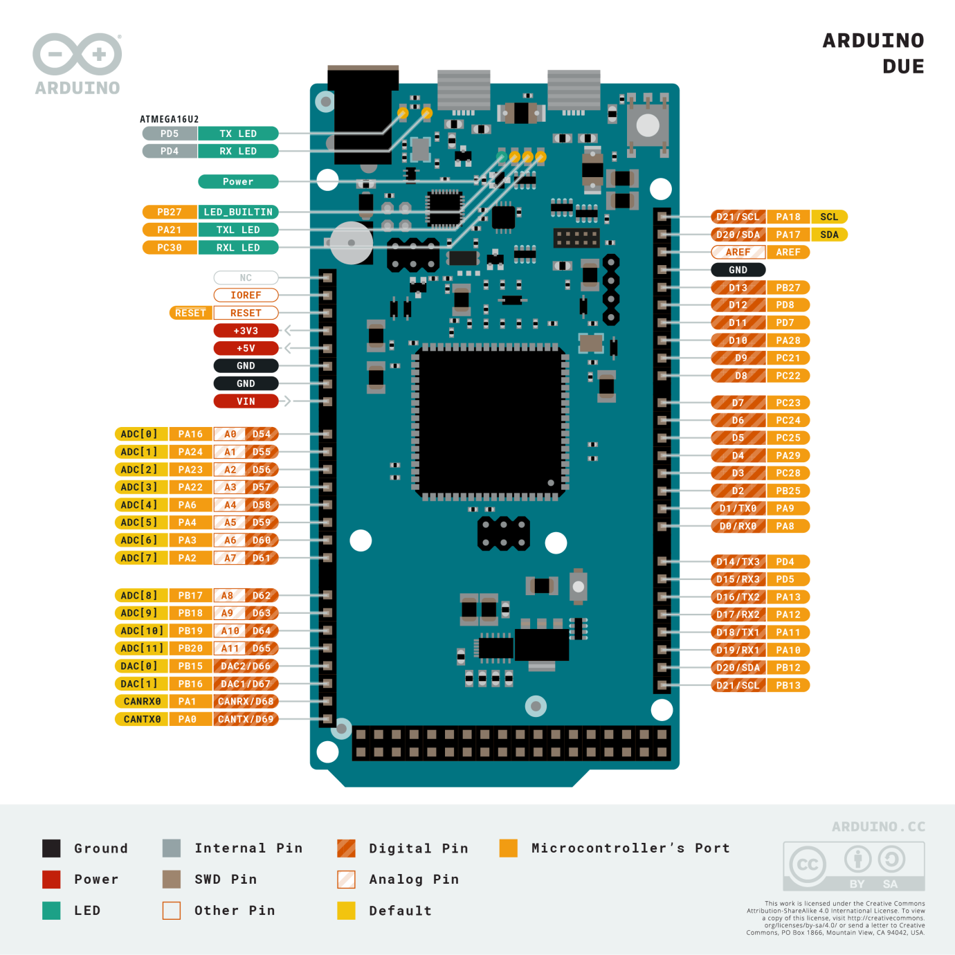

Figure 2: Arduino Due pinout

* **Processor:** Atmel SAM3X8E, featuring an ARM Cortex-M3 core. The Cortex-M3 is a 32-bit RISC processor implementing the ARMv7-M architecture, known for its balance of performance and energy efficiency. It includes a 3-stage pipeline and Harvard architecture (separate instruction and data buses).
* **Clock Speed:** 84MHz. This is derived from a PLL (Phase Locked Loop) driven by an external crystal.
* **Memory:**
  + **Flash Memory:** 512 KB, organized in two 256 KB banks. This allows for Read-While-Write (RWW) operations, potentially enabling bootloader updates or data logging without halting program execution.
  + **SRAM:** 96KB split into two contiguous banks: 64 KB (SRAM0) and 32 KB (SRAM1). This segmented SRAM can be accessed concurrently by different bus masters (e.g., CPU and DMA).
* **Operating Voltage:** 3.3V. A critical distinction from many 8-bit Arduinos, as applying 5V to I/O pins can permanently damage the SAM3X8E.
* **Digital I/O Pins:** 54, with extensive multiplexing for peripherals. 12 pins support Pulse Width Modulation (PWM).
* **Analog Capabilities:**
  + **Analog Input Pins (ADC):** 12 channels, multiplexed to a single 12-bit Analog-to-Digital Converter (ADC) capable of up to 1Msps.
  + **Analog Output Pins (DAC):** 2 channels, connected to a 12-bit Digital-to-Analog Converter (DAC), a rare feature on Arduino boards.
* **Communication Peripherals:**
  + 4 UARTs (hardware serial ports)
  + 2 TWIs (I2C compatible interfaces)
  + 1 SPI header (with advanced SPI features like chip select control)
  + 1 CAN interface (compliant with CAN 2.0A and 2.0B)
  + USB: One native USB OTG capable port (programming and host/device functionality) and one programming port (interfaced via an ATMega16U2).
* **DMA Controller:** The SAM3X8E includes a Central DMA (DMAC) controller, allowing peripherals to transfer data to/from memory without CPU intervention, significantly improving throughput for data-intensive tasks.
* **Other Features:** JTAG header for advanced debugging, erase button (to clear flash), reset button.

2.2. Software Ecosystem and Development Nuances  
Arduino Due is primarily programmed via the Arduino IDE using C++, the Due benefits from the Arduino abstraction layer. However, developers seeking maximum performance or access to all SAM3X8E features often delve into direct register manipulation or utilize Microchip's (formerly Atmel's) Software Framework (ASF).

* **Library Compatibility:** While many core Arduino libraries were ported, the 3.3V logic and different underlying hardware mean that libraries directly manipulating AVR registers or assuming 5V logic are incompatible or require significant modification.
* **Interrupts and Timers:** The ARM Cortex-M3 offers a more sophisticated Nested Vectored Interrupt Controller (NVIC) and more capable timers than AVRs, but leveraging these fully might require stepping outside standard Arduino functions.
* **Real-Time Operation**: While not an RTOS-centric platform out-of-the-box, the SAM3X8E can run RTOSs like FreeRTOS, ChibiOS, enabling more deterministic real-time applications.

2.3. Typical Applications and Design Philosophy  
The Due targets projects outgrowing the capabilities of 8-bit Arduinos:

* Complex robotics requiring multiple sensor inputs and motor controls.
* Basic digital audio processing leveraging the DACs and ADC.
* Automotive projects utilizing the CAN bus.
* Projects needing high I/O counts or multiple simultaneous serial communications.

### 2.4. Strengths and Limitations

* **Strengths:**
  + **High I/O Count:** Unmatched by most development boards in its class.
  + **Dual DACs:** Useful for analog signal generation.
  + **CAN Bus:** Integrated CAN controller is a significant advantage for automotive or industrial networking.
  + **Mature Cortex-M3 Core:** Well-understood architecture with good compiler and toolchain support.
  + **DMA:** Enables efficient data handling.
* **Limitations:**
  + **Strict 3.3V I/O:** Requires careful level shifting for 5V systems.
  + **Power Consumption:** Higher than many contemporary MCUs, especially newer Cortex-M0+ or M4 designs. Sleep modes are available but the platform isn't optimized for ultra-low power.
  + **Floating Point:** No hardware Floating Point Unit (FPU); floating-point operations are emulated in software, impacting performance.
  + **Form Factor:** Large Arduino Mega-like footprint is not ideal for space-constrained designs.
  + **Age:** While still capable, the SAM3X8E is an older design compared to newer ARM Cortex-M generations.

## 3. Adafruit Feather M4 Express

The Adafruit Feather M4 Express, based on the Microchip ATSAMD51J19A, is a flagship of Adafruit's Feather ecosystem, emphasizing high performance, ease of use with CircuitPython, and extensibility through FeatherWings.

3.1. Core Architecture and Detailed Specifications

The Feather M4 Express utilizes the Microchip ATSAMD51J19A MCU.

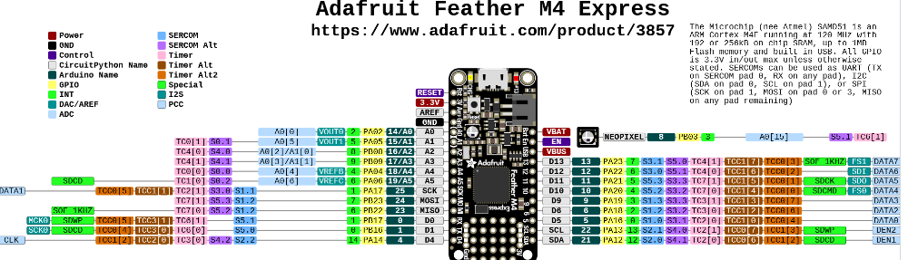

Figure 3: Adafruit Feather M4 Express pinout

* **Processor:** Microchip ATSAMD51J19A, featuring an ARM Cortex-M4F core. The Cortex-M4F includes a single-precision hardware Floating Point Unit (FPU) and DSP instructions, dramatically accelerating mathematical computations.
* **Clock Speed:** Typically 120 MHz, but the ATSAMD51 can be clocked up to 200 MHz in some configurations (though Adafruit's board runs it at 120 MHz for stability and power).
* **Memory:**
  + **Flash Memory (Internal):** 512 KB for program code. The SAMD51 features ECC (Error Correcting Code) on its flash memory.
  + **SRAM:** 192 KB, a substantial amount for complex applications and data buffering.
  + **External QSPI Flash**: 2 MB connected via a Quad Serial Peripheral Interface. This is primarily used by CircuitPython for storing the Python runtime, libraries, and user scripts as a small filesystem, but can also be used for general data logging.
* **Operating Voltage:** 3.3V logic and power.
* **Digital I/O Pins:** 21 GPIO pins. These are highly multiplexed via the SERCOM (Serial Communication Interface) system.
* **Analog Capabilities:**
  + **Analog Input Pins (ADC):** 6 pins multiplexed to two 12-bit ADCs (though typically one is used at a time for Arduino compatibility), capable of up to 1Msps.
  + **Analog Output Pins (DAC):** 1 pin connected to a 10-bit DAC.
* **Communication Peripherals (SERCOM):** The ATSAMD51 features multiple (typically 6-8 depending on package) highly configurable SERCOM peripherals. Each SERCOM can be independently configured as an I2C, SPI, or UART interface, offering great flexibility in peripheral assignment to pins.
  + Native USB (device and host capabilities).
  + I2S (Inter-IC Sound) interface for digital audio.
  + PDEC (Position Decoder) for quadrature encoder input.
* **DMA Controller:** A powerful DMA controller with multiple channels to offload data transfers.
* **Other Features:** Built-in LiPo battery charging circuitry, status NeoPixel RGB LED, SWD (Serial Wire Debug) port for advanced debugging.

3.2. Software Ecosystem and Development Nuances  
The Feather M4 Express shines with its dual support for:

* **Arduino IDE:** Programmed in C/C++ using Adafruit's SAMD core, which provides access to many ATSAMD51 features. Performance-critical applications often use this route.
* **CircuitPython:** A fork of MicroPython optimized for ease of use on Adafruit (and other) boards. It presents the QSPI flash as a USB drive, allowing for drag-and-drop code updates and rapid iteration. This significantly lowers the barrier to entry for Python developers.
* **RTOS Support:** The ATSAMD51 is well-suited for running RTOSs like FreeRTOS, and Adafruit provides examples.
* **Low-Level Access:** For advanced users, Microchip's Harmony framework or direct register programming can unlock the full potential of the ATSAMD51.

3.3. Typical Applications and Design Philosophy

The Feather M4 Express is designed for:

* IoT projects requiring connectivity, processing power, and low-power capabilities.
* Wearable technology and portable devices benefiting from the small form factor and battery management.
* Machine learning inference at the edge (e.g., TensorFlow Lite for Microcontrollers).
* Projects involving digital signal processing, audio synthesis, or sensor fusion thanks to the FPU and DSP instructions.
* Rapid prototyping and educational purposes due to CircuitPython's accessibility.

### 3.4. Strengths and Limitations

* **Strengths:**
  + **Powerful Cortex-M4F Core:** FPU and DSP instructions provide significant performance gains for specific tasks.
  + **Ample SRAM (192KB):** Facilitates complex algorithms and larger data sets.
  + **QSPI Flash:** Excellent for file storage, configuration data, or large CircuitPython applications.
  + **CircuitPython:** Superb for rapid development and ease of use.
  + **Integrated LiPo Charging:** Simplifies portable project design.
  + **Compact Feather Form Factor & Ecosystem:** Small size and wide range of plug-and-play FeatherWing add-ons.
  + **Advanced Peripherals:** Flexible SERCOMs, I2C, and PDEC.
  + **Power Efficiency:** The SAMD51 offers more granular power control and lower active power consumption relative to its performance compared to the SAM3X.
* **Limitations:**
  + **Fewer Total I/O Pins:** Compared to the Due, the 21 GPIOs can be limiting for I/O-heavy applications without expanders.
  + **Single DAC (10-bit):** Less analog output capability than the Due.
  + **Complexity:** The ATSAMD51's rich peripheral set and clocking system can be complex to configure at a low level.
  + **QSPI as System Drive:** While flexible, reliance on external QSPI for CircuitPython's core operation means the system is inoperable if this flash fails.

## 4. In-Depth Comparative Analysis: Arduino Due vs. Adafruit Feather M4 Express

|  |  |  |  |
| --- | --- | --- | --- |
| **Feature** | **Arduino Due (SAM3X8E)** | **Adafruit Feather M4 Express (ATSAMD51J19A)** | **Notes** |
| Processor Core | ARM Cortex-M3 @ 84 MHz | ARM Cortex-M4F @ 120 MHz | M4F includes single-precision FPU & DSP instructions, drastically outperforming M3 in math/signal processing. M4F also has slightly deeper pipeline. |
| SRAM | 96 KB (2 banks) | 192 KB | Feather M4's larger contiguous SRAM is crucial for RTOS, complex algorithms, large network buffers. Due's banked SRAM allows some concurrency. |
| Flash (Internal) | 512 KB (2 banks, RWW) | 512 KB (with ECC) | Due's RWW is good for firmware updates. Feather's ECC offers better data integrity for program code. |
| Flash (External) | None | 2 MB QSPI | Feather's QSPI is a major asset for data logging, CircuitPython environment, and large asset storage. |
| Floating Point Unit | No (Software Emulation) | Yes (Hardware Single-Precision) | Feather M4 is orders of magnitude faster for float operations (e.g., sensor fusion, FFTs, filtering). |
| Digital I/O | 54 | 21 | Due offers significantly more direct I/O. Feather relies on its ecosystem or I/O expanders for more connections. |
| Analog Inputs (ADC) | 12 channels (12-bit, 1 Msps) | 6 channels (12-bit, 1 Msps, dual ADCs available) | Due offers more raw analog input channels. Feather's SAMD51 ADC is quite capable and flexible. |
| Analog Outputs (DAC) | 2 channels (12-bit) | 1 channel (10-bit) | Due provides superior analog output capabilities. |
| Special Peripherals | CAN Controller, Ethernet (on variants not Due) | I2S, PDEC, Flexible SERCOMs | Due's CAN is unique. Feather's SERCOMs offer versatile I2C/SPI/UART configurations; I2S is good for audio. |
| Power Management | Basic sleep modes, generally higher consumption | Advanced sleep modes, power gating, lower active current | ATSAMD51 is designed for better power efficiency with more granular control. Feather board adds LiPo charging. |
| Form Factor | Arduino Mega size (101.5 x 53.3mm) | Feather size (51 x 23 mm) | Feather is vastly smaller and lighter, crucial for wearables, portables, and space/mass constrained systems. |
| Primary Software | Arduino IDE (C++), ASF | Arduino IDE (C++), CircuitPython, Microchip Harmony | Feather's CircuitPython enables rapid development. Both support C/C++ for performance. |
| Debugging | JTAG, Serial | SWD, Serial | Both offer robust hardware debugging. SWD uses fewer pins than JTAG. |
| Community & Ecosystem | Large, mature Arduino community. Less SAM3X specific. | Strong Adafruit/CircuitPython community, rich FeatherWing ecosystem. | Adafruit provides excellent libraries and support for its hardware. |

## 5. Suitability and Limitations in Satellite Projects

The use of COTS MCUs in space missions, especially CubeSats, is driven by pragmatism but fraught with risks associated with the space environment.

### 5.1. The Space Environment Challenges

* **Radiation:**
  + **Total Ionizing Dose (TID):** Accumulation of radiation dose over mission lifetime, leading to parametric degradation (e.g., increased leakage current, threshold voltage shifts) and eventual functional failure.
  + **Single Event Effects (SEEs):** Caused by individual high-energy particles.
    - **Single Event Upset (SEU):** Bit-flips in memory cells (SRAM, registers and configuration bits in FPGAs/MCUs). Can corrupt data or program flow.
    - **Single Event Functional Interrupt (SEFI):** A soft error that causes the device to enter an unexpected state, often requiring a reset or power cycle to recover.
    - **Single Event Latch-up (SEL):** A potentially destructive high-current state triggered in CMOS structures, requiring immediate power cycling to prevent permanent damage. COTS MCUs are often prone to SEL.
    - **Single Event Gate Rupture (SEGR) / Single Event Burnout (SEB**): Destructive events in power MOSFETs, less common in MCUs themselves but relevant for power systems.
* **Temperature Extremes & Cycling:** Satellites in LEO can experience temperature swings from -40°C to +85°C or wider. MCUs must operate reliably, and repeated cycling can cause mechanical stress.
* **Vacuum:** Outgassing of materials can contaminate sensitive optical surfaces or cause issues with high voltage components. Packaged MCUs are generally sealed, but PCBs and other materials are a concern.
* **Power Constraints:** Solar power and battery capacity are limited, mandating highly efficient power usage and robust sleep modes.
* **Reliability & Uptime:** Mission failure is costly. Systems must be robust, with fault detection, isolation, and recovery (FDIR) mechanisms.

### 5.2. Arduino Due (SAM3X8E) in Satellite Projects

* **Potential Suitability:**
  + **High I/O for Payloads:** If a mission requires interfacing with a large number of simple sensors or actuators directly, the Due's pin count is an advantage.
  + **CAN Bus for Intra-Satellite Communications:** Useful if a CAN bus is adopted for the satellite's internal data network.
  + **Familiarity for some teams:** The Arduino ecosystem can lower the entry barrier for software development if performance is not paramount.
* **Significant Limitations & Risks:**
  + **Radiation Susceptibility:** The SAM3X8E, being an older design on a larger process node, is highly susceptible to SEUs in its 96KB SRAM and registers. SEL risk is also present and needs characterization. TID tolerance is likely low.
  + **Power Consumption:** Higher active and sleep currents compared to more modern MCUs make it less suitable for power-starved missions.
  + **Lack of FPU:** Any calculations requiring floating-point (e.g., ADCS algorithms) will be slow.
  + **Form Factor & Mass:** The standard Due board is too large and heavy. A custom PCB with the SAM3X8E would be necessary, but the chip itself is also relatively large.
  + **Limited Error Mitigation Features:** Lacks internal ECC on SRAM. RWW on Flash is useful but doesn't protect against Flash SEUs directly.

### 5.3. Adafruit Feather M4 Express (ATSAMD51J19A) in Satellite Projects

* **Potential Suitability:**
  + **OBC/ADCS Processing**: The Cortex-M4F core with its FPU and DSP instructions is well-suited for attitude determination and control (e.g., running Kalman filters, processing IMU/star tracker data), and complex payload data processing.
  + **Data Logging & Storage:** The 2MB QSPI flash is invaluable for telemetry storage, scientific data buffering, or even holding larger mission software segments.
  + **Power Efficiency:** The ATSAMD51 offers better power management features (e.g., granular clock gating, multiple sleep modes) allowing for lower average power consumption if carefully managed.
  + **Compactness:** The ATSAMD51 chip itself allows for very dense custom board designs, fitting well within CubeSat volume constraints.
  + **ECC on Internal Flash:** Provides some protection against SEUs corrupting the program code.
* **Significant Limitations & Risks:**
  + **Radiation Susceptibility (SRAM & Peripherals):** The 192KB SRAM is highly vulnerable to SEUs. The complex peripherals and clocking system of the ATSAMD51 mean many configuration registers are also susceptible to SEUs, potentially leading to intricate SEFIs. SEL risk must be assessed.
  + **QSPI Flash Reliability in Space**: While useful, the radiation tolerance (TID and SEE) of generic QSPI flash chips used on development boards is often unknown and can be poor. Errors in QSPI could corrupt the CircuitPython environment or stored data. Careful selection of space-grade or radiation-tolerant QSPI flash would be ideal but adds cost and complexity.
  + **Software Complexity:** While CircuitPython aids rapid prototyping, flight software would likely be C/C++ with an RTOS or bare-metal for determinism and control. Managing the ATSAMD51's complexity (numerous clocks, peripherals, DMA) in a high-reliability context is demanding.
  + **Thermal Performance:** High clock speeds (120MHz+) can lead to significant heat generation in a vacuum where convective cooling is absent. Thermal analysis and mitigation (heatsinks, thermal pathways to chassis) are critical.

5.4. Essential Mitigation Strategies for COTS MCUs in Space  
Regardless of the choice, deploying COTS MCUs necessitates a robust FDIR strategy:

* **Hardware Watchdogs:** External watchdog timers are crucial to recover from SEFI-induced hangs. Internal watchdogs are a first line of defense.
* **Redundancy:**
  + **Component Redundancy:** Using multiple MCUs (e.g., two or three in a voting or hot/cold spare configuration) for critical functions.
  + **Data Redundancy:** Storing critical data with checksums, CRCs, or Reed-**Solomon codes.**
* **Software Fault Tolerance:**
  + **Memory Scrubbing:** Periodically reading and rewriting SRAM (if ECC is not present) or critical data areas to correct accumulated SEUs (requires knowing good values or using error codes).
  + **Defensive Programming:** Robust error handling, sanity checks, and safe-state fall-backs.
  + **Instruction/Task-Level TMR:** Triple Modular Redundancy for critical calculations or code sections, though this has high overhead.
* **Radiation Shielding:** Localized shielding (e.g., tantalum spots over sensitive chips) can reduce TID and somewhat lower SEE rates, but adds mass and may generate secondary particles.
* **Latch-up Protection:** Current limiting and fast power cycling circuitry to detect and mitigate SELs.
* **Thorough Testing:**
  + **Functional Testing:** Across the full expected temperature range in a thermal vacuum chamber.
  + **Radiation Beam Testing:** Exposing components to proton and heavy-ion beams to characterize SEE cross-sections, SEL thresholds, and TID tolerance. This is expensive but provides invaluable data.
* **System-Level Design:** Ensuring a robust power distribution system, careful clock management, and reliable inter-component communication.

## 6. Prices

The Arduino Due is locally available ranging from Ksh.4000- 5000 whereas the Adafruit feather M4 Express isn’t readily available and would have to be shipped from abroad. Its price tag is around $23 non-inclusive of shipping costs.

## 7. Conclusion

The Arduino Due and Adafruit Feather M4 Express are powerful 32-bit microcontrollers offering distinct advantages for terrestrial embedded applications. The Due excels with its sheer number of I/O pins and established Arduino ecosystem, making it suitable for complex interfacing tasks. The Feather M4 Express, with its faster Cortex-M4F core, FPU, integrated QSPI flash, and strong CircuitPython support, offers a compelling package for computationally intensive tasks, IoT, and rapid prototyping in a compact, power-conscious form factor.

For satellite projects, particularly cost-sensitive CubeSats, both platforms present the allure of COTS accessibility and performance. The Feather M4 Express appears slightly more advantageous due to its more modern core (Cortex-M4F with FPU), better potential power efficiency, and onboard QSPI flash for data storage. Its FPU is particularly beneficial for ADCS and complex sensor processing. The Arduino Due's main advantage would be its high I/O count if a mission absolutely required numerous direct connections without expanders.

However, neither is inherently designed for the harsh space environment. Their use necessitates a thorough understanding of their limitations, especially concerning radiation effects and temperature cycling. Significant effort in implementing hardware and software fault tolerance mechanisms, along with potential shielding, is mandatory. While COTS MCUs like these are making space more accessible, mission success relies heavily on rigorous testing, robust system design, and realistic expectations of their performance and reliability in orbit. Future research should continue to focus on characterizing COTS MCU behaviour in simulated space environments and developing standardized mitigation techniques.